Secret Manager for Development
Managing sensitive settings securely is critical during development. We'll move sensitive information, such as database connection strings and API keys, from the appsettings.json file to a secrets.json file. This prevents sensitive data from being exposed if appsettings.json is pushed to source control (e.g., GitHub).
Setting Up User Secrets  - Enable User Secrets in Visual Studio  - Right-click your project in Solution Explorer and select Manage User Secrets.  - This action creates a secrets.json file outside your project directory.  - Locate the secrets.json File  - Right-click on the secrets.json tab and select Copy Full Path.  - Paste the path into File Explorer to inspect the file.  Notice: The secrets.json file is stored in your user profile directory, making it inaccessible to source control and external parties. | 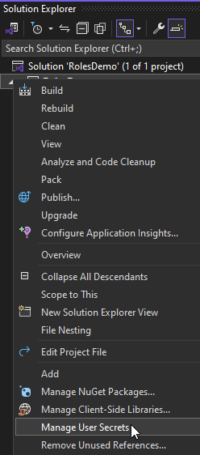

Moving Configuration to Secrets
- Transfer Settings
- Move sensitive configuration data from appsettings.json to secrets.json.
For example:
{
"ConnectionStrings": {
"DefaultConnection": "Data Source=sql.db"
},
"Recaptcha": {
"SiteKey": "6Le1NaAqAAAAAHaa0raVRRshlFpjcVyc60lop3Dw",
"SecretKey": "6Le1NaAqAAAAAJK6QSp9b0nPe9c6YOMyAcQnNbTT"
}
}

- Verify Secrets
- In the Package Manager Console, execute:
PM> | dotnet user-secrets list

- The secrets will be displayed, e.g.:
Recaptcha:SiteKey = 6Le1NaAqAAAAAHaa0raVRRshlFpjcVyc60lop3Dw
Recaptcha:SecretKey = 6Le1NaAqAAAAAJK6QSp9b0nPe9c6YOMyAcQnNbTT
ConnectionStrings:DefaultConnection = Data Source=sql.db
Note: The secrets.json file is separate from your project, ensuring sensitive data is not exposed when you publish to GitHub.

Consuming Secrets in Code
- Update Program.cs
Replace:
var connectionString =
builder.Configuration.GetConnectionString("DefaultConnection")
?? throw new InvalidOperationException("'DefaultConnection' not found.");
With.
var connectionString = builder.Configuration["ConnectionStrings:DefaultConnection"];
Note: The project knows where the secrets.json file is located, even though it is not visible in Solution Explorer.
- Access Secrets Another Way
Add dependency injection for IConfiguration in your controller or service to access secrets. For example, retrieve the reCAPTCHA keys in the Register.cshtml.cs file:
ViewData["SiteKey"] = _configuration["Recaptcha:SiteKey"];
string secret = _configuration["Recaptcha:SecretKey"];

Testing Secrets
Run the project and test sensitive data retrieval by registering a new user. Ensure that the sensitive configuration works as intended.

For Your Internal Project:
The SendGrid Key is not to be pushed to GitHub in the appsettings.json file. It must be saved in the secrets file. Then follow the steps below to get the secrets into Azure when publishing your application.

